Online Auction

Login Manual

**Slippery Rock University of Pennsylvania**

Contributions by:

**Spring 2024**

Wolfgang Zoppelt – wsz1001@sru.edu

**Installation**

To add WAR file generation capabilities to your GitHub repository you must follow these steps.

Step 1

Go under the actions tab in your GitHub Repository.

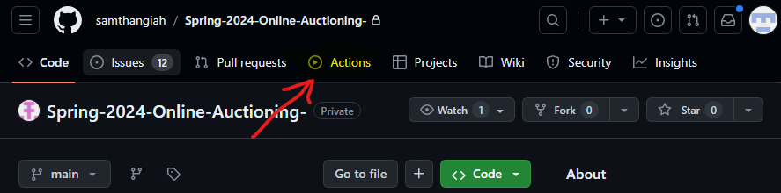

Step 2

Under the actions tab, click on the “New Workflow” button.

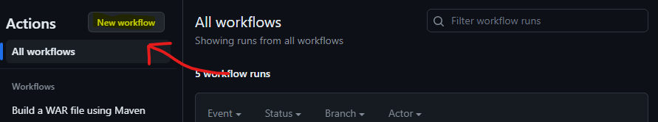

Step 3

In the “Choose a workflow” menu, select “Skip this and set up a workflow yourself”

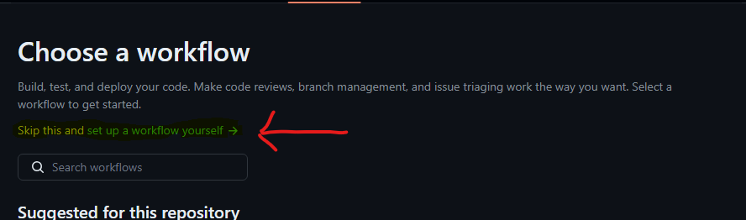

Step 4

In the workflow creation menu, name the “.yml” file at the top to a name of your choice. On this page, copy and paste the code below

#From https://www.coachdevops.com/2023/12/implement-cicd-using-github-actions.html

name: Build a WAR file using Maven

on:

workflow_dispatch:

jobs:

build:

runs-on: ubuntu-latest

steps:

- uses: actions/checkout@v3

- name: Set up JDK 17

uses: actions/setup-java@v2

with:

distribution: 'adopt'

java-version: '17'

- name: Build with Maven

run: mvn install --file *path/to/pom.xml* -DskipTests

#From https://docs.github.com/en/actions/automating-builds-and-tests/building-and-testing-java-with-maven

- run: mkdir staging && cp -r /home/runner/work/*name of repository*/*name of repository*/*workspace directory*/target/ staging

- uses: actions/upload-artifact@v4

with:

name: Package

path: staging

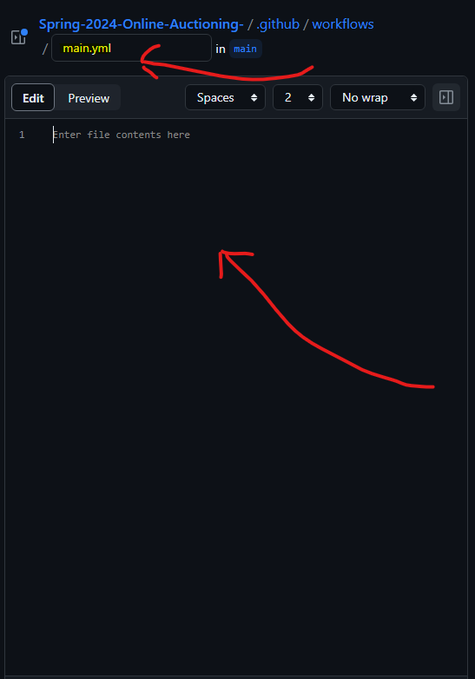

***Make sure to change the *path/to/pom.xml*, *repository name*, and *workspace directory* portions of the code to match your project.***

Step 5

When the previous step is complete, commit the changes to the repository.

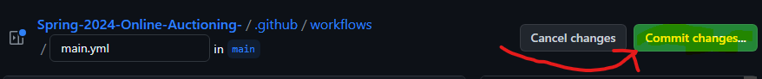

Step 6

After committing the changes, go back to your actions tab. You should now see a new workflow named “Build a WAR file using Maven”.

**Using the Workflow**

To use, click on the workflow.

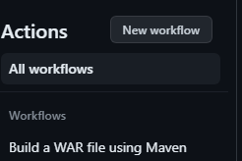

In the workflow menu, click on the “Run workflow” button. This will bring up a drop-down that allows you to choose what branch from which the workflow should create the WAR file. Once the appropriate branch is selected, select the green “Run workflow” button.

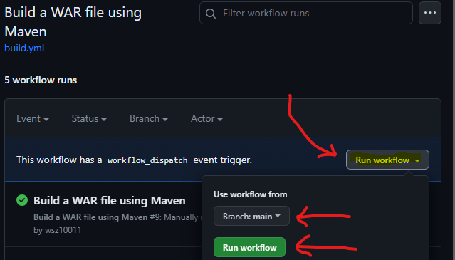

This will create a new workflow run. Once the workflow run takes its course, select the workflow run that you just created. In this menu you will see under the “Artifacts” table a file Package.zip. You can click on this file to download it. The file contains the WAR file generated during the workflow.

